Unit-2
Poly phase transformers
- Three Phase Transformer connections: -
The identical single phase transformers can be suitably inter-connected and used instead of a single unit 3 phase transformer. The single unit 3 phase transformer is housed in a single tank. But the transformer bank is made up of three separate single phase transformers each with its own, tanks and bushings. This method is preferred in mines and high altitude power stations because transportation becomes easier. Bank method is adopted also when the voltage involved is high because it is easier to provide proper insulation in each single phase transformer.
As compared to a bank of single phase transformers, the main advantages of a single unit 3-phase transformer are that it occupies less floor space for equal rating, less weight costs about 20% less and further that only one unit is to be handled and connected.
There are various methods available for transforming 3 phase voltages to higher or lower 3 phase voltages. The most common connections are (i) star — star (ii) Delta—Delta (iii) Star —Delta (iv) Delta — Star.
- star — star
In this type of connection, both the primary and secondary windings are connected in Star as shown in the Fig. 1. This particular connection proves to be economical for small high voltage transformers as phase voltage is (1/√3) times that of line voltage, the number of turns per phase and the quantity of insulation required is minimum. The ratio of line voltages on the primary and secondary sides is the same as the transformation ratio of each transformer. It can be noted that there is a phase voltage shift of 30° between the phase voltages and line voltages on both primary and secondary side. The line voltages on both sides and the primary voltages are in phase with each other.
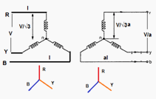
Fig.1 Star-star connection
The connection of primary neutral to the neutral of generator has an add advantage that it eliminates distortion in the secondary phase voltages. If the flux in the core has sinusoidal waveform, then it will give sinusoidal waveform for the voltage. But due to characteristic of iron, a sinusoidal waveform of flux requires a third harmonic component in the exciting current. As the frequency of this component is thrice the frequency of circuit at any given constant. it will try to flow either towards or away from the neutral point in the transformer windings. With isolated neutral, the triple frequency current cannot flow so the flux in the core will not be a sine wave and the voltages are distorted.
If primary neutral is connected to generator neutral the triple frequency currents get the path to solve the difficulty. The alternative way of overcoming with this difficulty is the use of tirtiary winding of low KVA rating. These windings are connected in delta and provides a circuit in which triple frequency currents can flow. Thus sinusoidal voltage on primary will give sinusoidal voltage on secondary side.
If V_{L1} is the line voltage on the primary side then phase voltage on primary side is given as,
$$V_{\text{ph}1}=\frac{V_{L1}}{\sqrt{3}}$$
If K is the turns ratio or transformation ratio then phase voltage on secondary side is given as,
... Secondary phase voltage, $V_{\text{ph}2}=K∗\frac{V_{L1}}{\sqrt{3}}$ as $\frac{V_{\text{ph}2}}{V_{\text{ph}1}}=K$
Note: Suffix 1 indicates primary side whereas suffix 2 indicates secondary side.
The line voltage on secondary side is given as,$V_{L2}=\sqrt{3}V_{\text{ph}2}=\sqrt{3}K\left(\frac{V_{L1}}{\sqrt{3}}\right)={\text{KV}}_{L1}$

Key point: The line voltage on secondary side is K times line voltage on primary side.

Advantages
- Due to star connection, phase voltages is (1/√3) times the line voltage. Hence less number of turns are required. Also the stress on insulation is less. This makes the connection economical for small high voltage purposes.
- Due to star connection, phase current is same as line current. Hence windings have to carry high currents. This makes cross section of the windings high. Thus the windings are mechanically strong and windings can bear heavy loads and short circuit.
- There is no phase shift between the primary and secondary voltages.
- As neutral is available, it is suitable for three phase, four wire system.

Disadvantages
- If the load on the secondary side unbalanced, then the performance of this connection is not satisfactory then the shifting of neutral point is possible. To prevent this, star point of the primary is required to be connected to the star point of the generator.
- Even though the star or neutral point of the primary is earthed, the third harmonic present in the alternator voltage may appear on the secondary side. This causes distortion in the secondary phase voltages.

Key point: Due to the disadvantages, this connection is rare in practice and used only for small high voltage transformers.

- Delta—Delta
In this type of connection, both the three phase primary and secondary windings are connected in delta as shown in the Fig. 2.
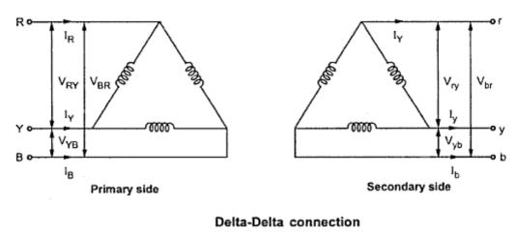
Fig. 2

The voltages on primary and secondary sides can be shown on the phasor diagram as shown in the Fig. 3
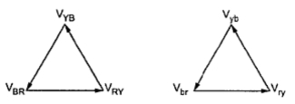
Fig. 3

The another way of representing this type of connection is shown in the Fig. 2.

This connection proves to be economical for large low voltage transformers as it increases number of turns per phase.
Key point: It can be seen that there is no phase shift between primary and secondary voltages.
V_{L1} = Line voltage on primary side.
V_{L2} = Line voltage on secondary side.
V_{ph1} = phase voltage on primary side.
V_{ph2} = Phase voltage on secondary side.
K = Transformer ratio.
For delta connection, V_{L1} = V_{ph1}
Now since V_{ph2} /V_{ph1} = K
... V_{ph2} = K V_{ph1}
But again since secondary is connected in delta
V_{L2} = V_{ph2} = K V_{L1}
Advantages
- in order to get secondary voltage as sinusoidal, the magnetizing current of transformer must contain a third harmonic component. The delta connection provides a closed path for circulation of third harmonic component of current. The flux remains sinusoidal which results in sinusoidal voltages.
- Even if the load is unbalanced the three phase voltages remains constant. Thus it allows unbalanced loading also.
- The important advantage with this type of connection is that if there is bank of single phase transformers connected in delta-delta fashion and if one of the transformers is disabled then the supply can be continued with remaining two transformers of course with reduced efficiency.
- There is no distortion in the secondary voltages.
- Due to delta connection, phase voltage is same as line voltage hence winding have more number of turns. But phase current is (1/√3) times the line current. Hence the cross-section of the windings is very less. This makes the connection economical for low voltages transformers.

Disadvantages
- Due to the absence of neutral point it is not suitable for three phase four wire system.
Key point: The connection is commonly used for large low voltage transformers.

- Star —Delta
In this type of connection, then primary is connected in star fashion while the secondary is connected in delta fashion as shown in the Fig. 4.

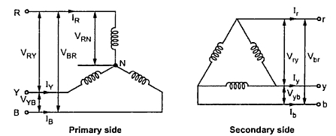
Fig. 4

The voltages on primary and secondary sides can be represented on the phasor diagram as shown in the Fig.5.
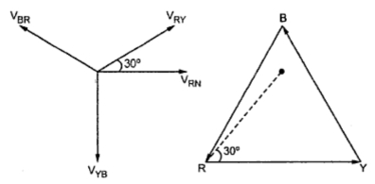
Fig. 5

This type of connection is commonly employed at the substation end of the transmission line. The main use with this connection is to step down the voltage. The neutral available on the primary side is grounded. It can be seen that there is phase difference of 30° between primary and secondary line voltages.
Key point: The delta connection on secondary side allows third harmonic current to flow which provides a sinusoidal flux.
Let V_{L1} = Line voltage on primary side.
V_{L2} = Line voltage on secondary side.
V_{ph1} = Phase voltage on primary side.
V_{ph2} = Phase voltage on secondary side.
K = Transformer ratio.
V_{ph1} = V_{L1}/√3
Now V_{ph2} /V_{ph1} = K
... V_{ph2} = K V_{ph1} = K (V_{L1}/√3)
Since secondary is connected in delta.
V_{ph2} = V_{L2}
V_{L2} = K (V_{L1}/√3) = (K/√3) V_{L1}
The connection suffers no problems due to unbalanced load as Secondaries are connected in delta. This type of transformers are commonly employed at receiving end.

Advantages
- The primary side is star connected. Hence fewer number of turns are required. This makes the connection economical for large high voltage step down power transformers.
- The neutral available on the primary can be earthed to avoid distortion.
- Large unbalanced loads can be handled satisfactory.

Disadvantages
In this type of connection, the secondary voltage is not in phase with the primary. Hence it is not possible to operate this connection in parallel with star-star or delta-delta connected transformer.

- Delta-Star
In this type of connection, the primary connected in delta fashion while the secondary current is connected in star fashion as shown in the Fig.6.

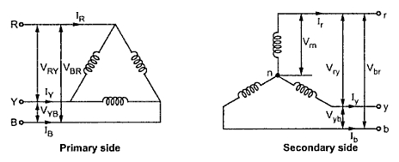
Fig.6

The voltage on primary and secondary side can be represented on the phasor diagram as shown in the Fig. 7.
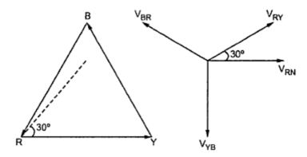
Fig.7

The main use of this connection is to step up the voltage i.e. at the beginning of high tension transmission system. It can be noted that there is a phase shift of 30° between primary line voltage and secondary line voltage as leading.
Key point: As secondary side is star connected, use of three phase, four wire system is possible.
Thus single phase and three phase loads can be supplied with this type of connection.
Let V_{L1} = Line voltage on primary side.
V_{L2} = Line voltage on secondary side.
V_{ph1} = Phase voltage on primary side.
V_{ph2} = Phase voltage on secondary side.
K = Transformation ratio.
As primary in delta connected,
V_{L1} = V_{ph1}
Now, V_{ph2}/V_{ph1} = K
... V_{ph2} = K V_{ph1}
Here secondary is connected in star
V_{L2} = √3 V_{ph2}
V_{L2} = (√3 K) V_{ph1}
V_{L2} = (√3 K) V_{L1}

The advantages and disadvantages with this type of connection are given below.
Advantages
- On primary side due to delta connection winding cross-section required is less.
- On secondary side, neutral is available, due to which it can be used for 3-phase, 4 wire supply system.
- There is no distortion due to third harmonic components.
- The windings connected on star makes it economical due to saving in cost of insulation.
- Large unbalanced loads can be handled without any difficulty.
Disadvantages
Due to phase shift between primary and secondary voltages, the limitation of Star-Delta connection continues for this type of connection as well.

Zig-zag Connection of Transformer
- The zigzag connection is also called the interconnected star connection. This connection has some of the features of the Y and the ∆ connections, combining the advantages of both.
- The zigzag transformer contains six coils on three cores. The first coil on each core is connected contrariwise to the second coil on the next core. The second coils are then all tied together to form the neutral and the phases are connected to the primary coils. Each phase, therefore, couples with each other phase and the voltages cancel out. As such, there would be negligible current through the neutral pole and it can be connected to ground
Delta-zigzag (Dz0) connection
In zig zag transformer connection, there are three windings on each of the three limbs of the core, one for primary and two for secondary. Both the windings of secondary are of equal turns.
The windings A1A2, a1a2 and a3a4 are wound on the same limb of the core hence they are all coloured in red. Similarly the other windings.
The required windings connections are derived from the phasor diagram to meet required vector group as shown in figure.1.
Here for Dz0, the phase difference between primary and secondary is 0 degree. We have to connect the windings in such a way so that it will give zero degree phase displacement between the primary and secondary (or say the primary and secondary are in phase).
See the diagram how connections are done to achieve a zigzag connection in the secondary.In the primary side A2, B2 and C2 are the terminals brought out at the transformer bushings. In the secondary side a4, b4 and c4 are the terminals brought out at the transformer bushings. Other terminals are internally connected.
Connect the primary side in Delta as usual.
Then draw Delta (primary) side phasors.
NA2 phasor corresponds to a phase voltage in primary side. N is the virtual neutral, which does not exist physically in delta side, but found geometrically from the diagram. For obtaining the Dz0 configuration, the secondary ‘z’ side phasor diagram should be such so that the corresponding phase voltage (na4 here) phasor should be parallel to NA2. This zero phase displacement can be obtained by connecting the windings a3a4 with b2b1 (in other limb) in series. Clearly b1 should be connected to a3 and not the other ways.
The resultant phasor is the sum of the two phasors.
na4 = b2b1 + a3a4
Voltage phasors b2b1 and B1B2 are out of phase (180 degree phase difference), so the arrow head direction. Above addition is the phasor addition and not the arithmetic one.
Similarly obtain the resultant phasors for other two phases by recognizing the symmetry.
This way we get the secondary neutral point 'n' by connecting a2, b2 and c2 together. Of course unlike the primary side neutral 'N', here the secondary side neutral 'n' is real and brought out at the bushing.
So in this way we can realize the connection of windings from the phasor diagram. Accordingly the windings are connected. It is important that we realised the connection from the phasor diagram and rearranged the windings in Delta and Zigzag shape for better view.

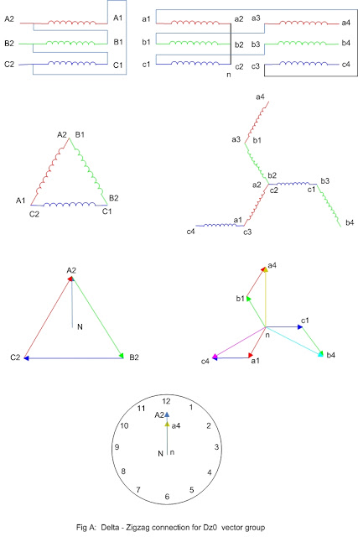

Delta-Zigzag (Dz6) connection
Here the primary side connection is same as previous case. In the secondary side we have just reversed the direction of phasors in previous case and automatically get Dz6 vector group. Of course now the phasors are rearranged to obey the rules of phasor addition.
For phase 'a', na3=b1b2+a4a3. Compare it with previous Dz0 case.
- Now the phasors are reversed and b2 is required to be connected to a4 (in Dz0 case b1 is connected to a3
- Terminal a3 not (a4) is brought out at the transformer bushing
- Secondary side neutral 'n' is obtained by connecting a1, b1 and c1 together
Now the secondary side windings are connected as per the phasor diagram. See fig-B

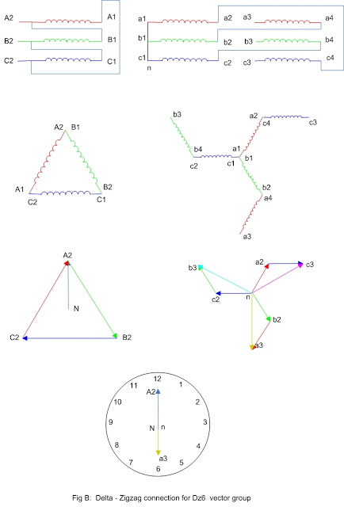
Star-Zigzag (Yz1) connection
Below (fig-C) is the connection and phasor diagram of Yz1 notation. It is left for the reader to verify the vector group. The reader should also practice the connections for other vector groups and corresponding phasor diagrams.

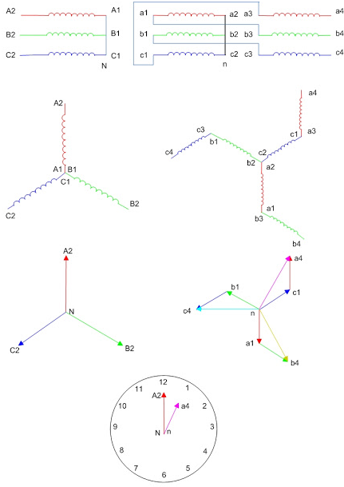

Zig Zag Transformer applications or uses

Grounding Transformer
It can be used as earthing transformer in a delta connected (no neutral terminal) system or an ungrounded start connected (three terminal star) where in neutral is not available for grounding. The zig zag transformer used for earthing of delta connected transformer.
In delta connected transformer there will not be path to zero sequence components and no protection can be performed for these components which increases and stress and heating in the windings. The zig zag transformer provides a neutral for the proving a path to zero sequence components during line to ground fault and allows the protection to be operated due to this fault. In the obsence of grounded neutral, voltages of healthy would increase line to line voltage level, stressing the insulation connected to equipment. Thug Zig zag transformer not only helps in protection it also reduces the voltages stress under symmetrical fault conditions.

2) Power Electronic converters
In power electronic converters the zig zag transformer is used to eliminate the DC magnetizing component presented due to improper firing angles. The improper firing angles of power electronic components (SCR) may introduce DC magnetizing component and this is cancelled in each limb of zig zag transformer due to opposite direction of DC magnetizing component of currents flowing in the windings on the same limb.

3) Earthling reference or earthling transformer
Zig zag transformer offers low impedance path to zero sequence components under fault conditions so it can be perfectly used as earthing transformer with and earthling reference. If the earthling current has to be limited under fault conditions, a suitable resistor can be placed in zig zag neutral terminal.
4) Harmonic voltages presented in system to some extent can be cancelled in zigzag windings due to opposite connection of winding coils.

Advantage of Zig zag transformer
The following are the advantages of zigzag transformer compared to Scott transformer and other grounding transformers
- Less cost compared to Scott transformer
- Provides low impedance to zero sequence currents
- Harmonic voltages suppression
- It provides perfect isolation between ground and component

Open Delta or V-V Connection of 3-Phase Transformer
As seen previously in connection of three single phase transformers that if one of the transformers is unable to operate then the supply to the load can be continued with the remaining two transformers at the cost of reduced efficiency. The connection that obtained is called V-V connection or open delta connection.
Consider the Fig. 1 in which 3 phase supply is connected to the primaries. At the secondary side three equal three phase voltages will be available on no load.
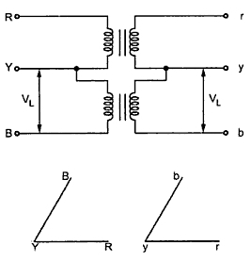
Fig. 1
The voltages are shown on phasor diagram. The connection is used when the three phase load is very very small to warrant the installation of full three phase transformer.
If one of the transformers fails in ∆ - ∆ bank and if it is required to continue the supply eventhough at reduced capacity until the transformer which is removed from the bank is repaired or a new one is installed then this type of connection is most suitable.
When it is anticipated that in future the load increase, then it requires closing of open delta. In such cases open delta connection is preferred.
Key point : It can be noted here that the removal of one of the transformers will not give the total load carried by V - V bank as two third of the capacity of ∆ - ∆ bank.
The load that can be carried by V - V bank is only 57.7% of it. it can be proved as follows.
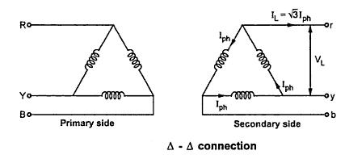
Fig. 2(a)

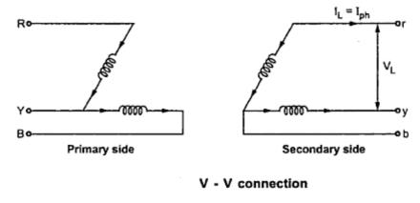
Fig. 2(b)
It can be seen from the Fig. 2(a)
∆ - ∆ capacity = √3 V_{L} I_{L} = √3 V_{L} (√3 I_{ph} )
∆ - ∆ capacity = 3 V_{L} I_{ph} ............(i)
It can also be noted from the Fig. 2(b) that the secondary line current I_{L} is equal to the phase current I_{ph}.
V- V capacity = √3 V_{L} I_{L} = √3 V_{L} I_{ph} ...............(ii)
Dividing equation (ii) by equation (i)
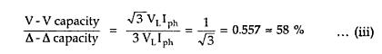
Thus the three phase load that can be carried without exceeding the ratings of the transformers is 57.5 percent of the original load. Hence it is not 66.7 % which was expected otherwise.
The reduction in the rating can be calculated as {(66.67 - 57.735)/(57.735)}x 100 = 15.476
Suppose that we consider three transformers connected in ∆ - ∆ fashion and supplying their rated load. Now one transformer is removed then each of the remaining two transformers will be overloaded. The overload on each transformer will be given as,
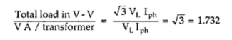

Key point : This overload can be carried temporarily if provision is made to reduce the load otherwise overheating and breakdown of the remaining two transformers would take place.

Limitations
The limitation with V -V connection are given below :
- The average p.f. at which V- V bank is operating is less than that with the load . This power p.f is 86.6 % of the balanced load p.f.
- The two transformers in V -V bank operate at different power factor except for balanced unity p.f .load.
- The terminals voltages available on the secondary side become unbalanced. This may happen eventhough load is perfectly balanced.
Thus in summary we can say that if two transformers are connected in V - V fashion and are loaded to rated capacity and one transformer is added to increase the total capacity by √3 or 173.2 %. Thus the increase in capacity is 73.2 % when converting from a V - V system to a ∆-∆ system.
With a bank of two single phase transformers connected in V-V fashion supplying a balanced 3 phase load with cosΦ asp.f., one of the transformer operate at a p.f. of cos (30-Φ) and other at cos (30+Φ). The powers of two transformers are given by,
P₁ = KVA cos (30-Φ)P₂ = KVA cos (30+Φ)
Example :
A ∆ -∆ bank consisting of three 40 KVA, 2300/230 V transformers supplies a load of 80 KVA. If one transformer is removed, find for the resulting V - V connection
i) KVA load carried by each transformer
ii) percent of rated load carried by each transformer
iii) total KVA rating of the V - V bank
iv) ratio of the V - V bank to ∆ - ∆ bank transformer ratings
v) percent increase in load on each transformer when bank is converted into V - V bank.
Solution
i) KVA load carried by each of the transformer is calculated as,
(Total KVA load in V - V bank)/(KVA load carried per transformer) = √3
KVA load carried per transformer = (Total KVA load)/√3 = 80/ √3 = 46.18 KVA
ii) Percent of rated load carried by each transformer = (KVA / transformer)/(KVA rating / transformer)
= 46.18/40 = 115.45%
iii) KVA rating of V - V bank = (3 x 40) x 0.577 = 120 x 0.577 = 69.24
iv) (V -V rating)/(∆ - ∆ rating) = 69.24/120 = 0.577 or 57.7%
v) Load supplied by each transformer in ∆ - ∆ bank = 80/3 = 26.66 KVA
% increase in load supplied by each KVA load/transformer in transformer
= (V- V bank)/(KVA load / transformer in ∆ - ∆ bank) = 46.18 / 26.66 = 1.732 or 173.2%

Conversion From Three Phase to Two phase (Scott Connection)
With the help of Scott connection, proposed by C.F. Scott, it is possible to obtain 2phase supply which is required for furnaces or even three phase load can be driven from the available 2phase supply source. The Scott connection which is serving this purpose is shown in the Fig.1.
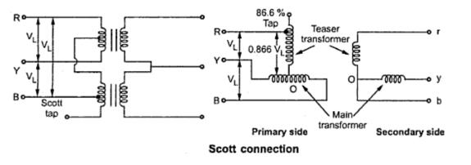
Fig. 1
This connection uses two transformers with different rating. But identical transformers with suitable tapping may also be used for the interchangeability and provision of spares. One of the transformers having 50% taping is called main transformer and other one having 86.6% tapping is called teaser transformer. If the Secondaries of the two transformers are connected as shown in the Fig. 1 then two phase, three wire system is obtained.
One end of the primary winding of the teaser transformer is connected to the centre tapping provided on the primary winding of the main transformer. The two ends of the primary winding of the main transformer and 86.6 tapping point on the teaser transformer is connected to a balanced three phase supply. The voltage per turn is same both in primary of both main and teaser transformers. With the equal number of turns on Secondaries of both the transformers, the secondary voltage will be equal in magnitude which results in symmetrical 2phase system.
The same connection drawn slight differently is shown in the Fig. 2.
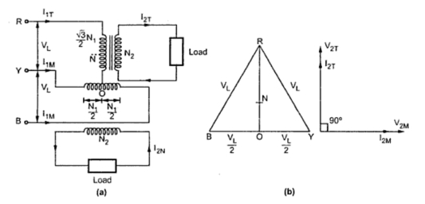
Fig. 2
The main transformer primary winding consists of N₁ turns connected between lines Y and B of a symmetrical three phase supply. V_{RY,} V_{YB} and V_{BR} are all line voltages. Hence VRY= V_{YB} = V_{BR} = V_{L} . But RO being the altitude of the equilateral triangle, the voltage V_{RO} is (√3/2)V_{L}. The voltage per turn will be same in primaries of both the transformers if number of turns between R and O are (√3/2)N₁. With this then the terminal voltages on the secondary windings having same turns will be equal in magnitude and have a same difference of between them.
The point O is not the neutral point of 3 phase supply voltage as its voltage with respect to any line is not V_{L}/√3. N is the neutral point shown in Fig. 3. Voltage V_{RN} is nothing but V_{L}/√3 whereas V_{RO} is (√3/2)V_{L}. Hence the voltage between N and O will be
(√3/2)V_{L} - (1/√3)V_{L} = 0.288 V_{L} ~ 0.29V_{L}
Since 0.29 is one third of 0.866, N divides the teaser winding RO in the ratio 2 :1.
Now let us consider the unity power factor load. The teaser secondary is supplying a current of I_{2T} . Neglecting the magnetizing current, we have I_{O} we have,
Transformation ratio, K = I_{1T}/I_{2T} = N₂ /N₁
Consider, I_{1T}/I_{2T} = N₂/N₁
I_{1T} = I_{2T} x (N₂ /((√3/2)N₁)) = (2/√3) (N₂/N₁) I_{2T}
=1.15 ( N₂/N₁) I_{2T}
... I_{1T} = 1.15 K I_{2T} ..................(i)
Each half on the primary winding of the main transformer carries current of consisting of I_{1m} two parts.
i) First part balances the main secondary current
I_{1M} = ( N₂/N₁) I_{2M} = K I_{2M}
ii) The second part is equal to one half of the teaser primary current i.e. 0.5 I_{1T}
The main transformer primary winding forms a return path for the teaser primary current which is divided into two halves at point O in either direction.
The current in each half is equal to (I_{1T}/2)=((1.15 K I_{2T} ) /2) = 0.58 K I_{2T}
This current is shown in the Fig. 3
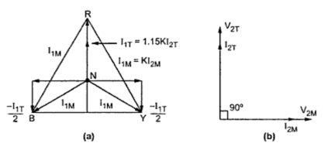
Fig. 3
Thus the phase R supplies current I_{1T} which is divided into equal parts and is flowing in the main transformer in the opposite directions. Thus the line currents on the primary side are vectorially given by,
Ī_{R} = Ī_{1T}
Ī_{Y} = Ī_{1M} - 0.5 Ī_{1T} = Ī_{1M} - 0.5 Ī_{1T}
Ī_{B} = -Ī_{1M} - 0.5 Ī_{1T} = - Ī_{1M} - 0.5 Ī_{1T}
The magnitude of these line currents are given by,
I_{R} = I_{1T}
I_{Y} = I_{B} = √(( I_{1M} )² + (0.5 I_{1T} )²)
The currents in the lines Y and B are obtained vectorially. The teaser transformer currents flowing in the two halves of the primary winding of the main transformer in the opposite direction and have no magnetic effect on the core and does not take part in balancing the secondary ampere turns of the main transformer. Thus when two phase load of unity power factor is balanced then three phase side is also balanced.
Now let us consider balanced row phase load at a lagging p.f. of cosΦ. The corresponding phasor diagram is shown in the Fig. 4. The three phase side is again balanced as the currents drawn from the three phase system are equal balanced and lag by angle Φ with respect to their respective phase voltages. This can be shown mathematically.
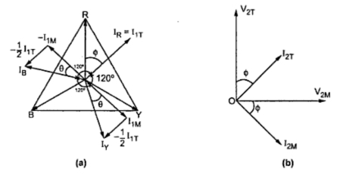
Fig. 4
Let us consider the equal currents at a power factor of cos Φ lagging from secondary side
... I_{2T} = I_{2M} = I₂
From the phasor diagram we have
I_{R} = I_{1T}
I_{Y} = I_{B} = √(( I_{1M})² + ( 0.5 I_{1T})²)
Now, I_{1M} = K I_{2M} = K I₂
I_{1T} = 1.16 K I_{2T} = 1.16 K I₂
Substituting I_{R} = 1.16 K I₂
I_{Y} = I_{B} = √((K I₂)²+(0.5 x1.16 I₂)²)
= 1.16 K I₂
Thus all the currents in the primary side are equal in magnitude.
We have from the phasor diagram
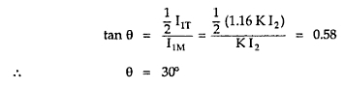

Since the power factors of the load for the main transformer and the teaser transformer are equal, the phase angle between the secondary currents is also 90°. The angle between the primary currents I_{1T} and I_{1M} is also 90°. Thus the three line currents I_{R} ,I_{Y} and I_{B} are displaced from each other by 120° and lag the respective phase voltages by an angle Φ. This proves that if the two phase load is balanced then the loading on the three phase side is also balanced.
Now we will consider the case of unbalanced two phase load having different currents and different power factors. The phasor diagram for this case can be constructed in a similar manner. It is shown in the Fig. 5.
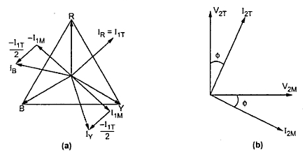
Fig. 5
Example 1 : Two transformers are required for a Scott connection operating from a 415 V, 3 phase supply for supplying two single phase furnaces 225 V on the two phase side. If the total output is 150 KVA, calculate the secondary to primary turns ratio and the winding currents for each transforme.
Solution : For the main transformer
Primary voltage = 415 V
Secondary voltage = 225 V
Transformation ratio, K = Secondary voltage / Primary voltage = 225/415 = 0.5421
Turns ratio = N₂/N₁ = 0.5421
Secondary current = (150 x 10³)/( 2 x 225) = 30 A
Primary current = 300 x 0.5421
= 162.63 A
For teaser transformer
Primary voltage = (√3/2) x 415 = 359.40 V
Secondary voltage = 225 V
Transformation ratio, K = Secondary voltage/ Primary voltage = 225/359.4 = 0.6260
Turns ratio, K = N₂/N₁ = 0.6260
Example 2 : In a Scott connection, calculate the values of line currents on the three phase side, if the loads on 2 phase side are 300 kW and 400 kW, both at 125 V and 0.707 p.f. and the three phase line voltage is 3300 V. The 300 kW load is on the leading phase of the 2 phase side. Neglect the losses.

Solution :
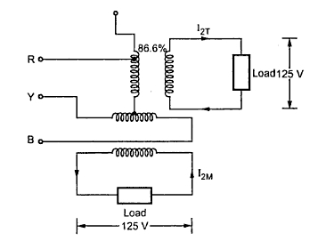
Primary line voltage = 3300 V
Secondary voltage = 125 V
Load carried by teaser secondary = 300 kW at 0.707 p.f.
Load carried by main secondary = 400 kW at 0.707 p.f.
Transformation ratio for main transformer, K =V₂ /V₁ = 125/3300 = 0.0378
Transformation ratio for teaser transformer, K = 1.1547 x Transformation ratio for main transformer
= 1.1547 x 0.0378 = 0.0436
Power supplied by teaser transformer = 300 kW at 0.707 p.f.
Secondary current in teaser transformer, I_{2T} = (300 x 10³) / (125 x 0.707) = 3394.62 A
Primary current in teaser transformer, = Transformation ratio for teaser transformer x I_{2T}
= 0.0436 x 3394.62 = 148 A
... Line current, I_{R} = 148 A
Power supplied by main transformer = 400 kW at 0.707 p.f.
Secondary current in main transformer, I_{2M}= (400 x 10³) / (125 x 0.707) = 4526.16 A
Primary current in main transformer, I_{1M}= K . I_{2M}
= 0.0378 x 452.16 = 171.08 A
In addition to this current each half of the primary winding of the main transformer carries half of teaser primary current.
I_{1T} = 148 A ; I_{1T} /2 = 148/2 = 74 A
Total current carried = √((I_{1M})² + (I_{1T} /2)²) = √((171.08)² + (74)²) = 186.39 A
I_{Y} = I_{B} = 186.39 A
The three line currents are I_{R} = 148 A, I_{Y} = 186.39 A, I_{B}= 186.39 A

- Testing of three phase transformers

- Voltage Ratio Measurement
a) Purpose of the test
To determine
a. Any abnormality in tapings in the winding
b. Any abnormality in the winding
c. Result ensures the inductance property of the transformer
b) Principle of the Test
The total voltage induced into the secondary winding of a transformer is proportional to the number of turns in the primary to the number of turns in the secondary, and by the amount of voltage applied to the primary.
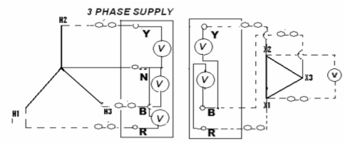
c) Procedure for the Test
1. Keep the tap position of the transformer in lowest position and LV in open
2. The voltage should be applied in the high voltage winding in order to avoid unsafe voltage
3. Apply 3 phase 415 V on HV terminals
4. Measure the voltage on each phase (ph-ph) on HV and LV terminals simultaneously.
5. Ratio measurement must be made on all the taps to confirm the proper alignment and operation of the tap changer.
6. Calculate the turns ratio in each tap position of tap: Vp/Vs
2. Magnetizing Current Test
a) Purpose of the Test
Excitation/ Magnetizing current test is performed to locate defect in magnetic core structure, shifting of windings, failure in turn to turn insulation or problem in tap changer.
b) Principle of the Test Excitation/ Magnetizing current is the current required to force a given flux through the core. It is the RMS value of the current flowing through a line terminal of a winding when voltage is applied at rated frequency, the other winding being open circuited.
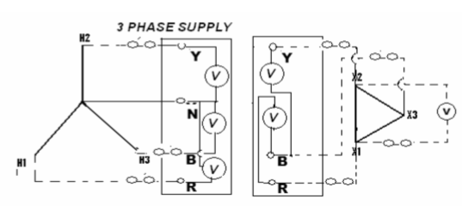

c)Procedure for the Test
1. Apply 3 phase 440 V AC supply on HV terminals and keep LV open.
2. Measure current in all the three phases.
3. Carry out the test on max., normal and min. tap position.
4. Repeat the test for LV side.
3. Magnetic Balance Test
a) Purpose of the Test
To check the balance in the magnetic circuit (core balance) in three phase transformers. It verifies core balance.
b) Principle of the Test
The voltage should be applied in one phase and measured in the other two phase of the winding. The sharing of the voltage will be maximum in the next phase of the winding (clock wise) more than 60% of the injected voltage and minimum voltage appear in another phase of the winding (clock wise) less than 40% of the injected voltage.
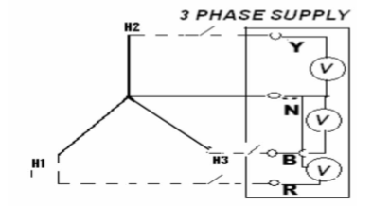
c) Procedure for the Test
1. For delta connected winding, apply 3 phase 440 V between phase to phase of a winding and measure the voltage induced in other two phases of the same winding.
2. For star winding, apply 1 phase 230 V between phase and neutral and measure the voltage induced in other two phases of the same winding.
3. Similarly all the phase should be checked with reference to other two phases
4. Winding Insulation Resistance Measurement
a) Purpose of the Test
This test reveals the condition of voids in the dielectric insulations like solid insulation in the winding due to heat or moisture, any dampness solubility in the oil, presence of any foreign objects which is having the corrosive characteristic present in the bushing.
b) Principle of the Test
If a test voltage ids applied across a piece of insulation, then by measuring the resultant current and applying ohm’s law (R=E/I), the resistance of the insulation can be calculated. Effect of temperature in measurement. For every 10 deg increase in temperature, half the resistance; or for every 10 deg increase in temperature, double the resistance. For example, a 100 Gohm resistance at 20 deg becomes 25 Gohm at 40 deg. Cen.
  - HV/E+LV Shorted
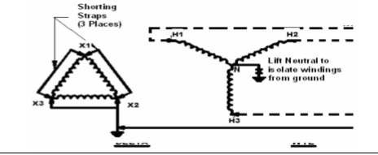
  - LV/E + HV Shorted
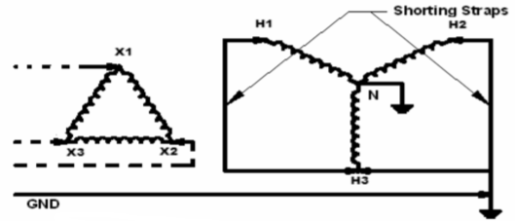
  - HV /LV + Ground Open
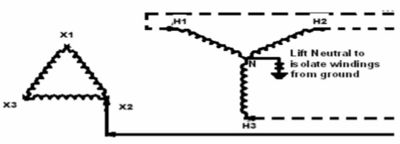
c) Procedure for the Test
1. Connect leads to HV winding and LV winding to measure IR between windings.
2. Apply 5 KV and take measurement at interval of 15 sec, 60 sec and 600 sec
3. Connect leads between winding and earth to measure IR between winding and earth.
4. Keep the other windings shorted and earthed.
5. Repeat the test.

5. Verification of Vector Group and Polarity
a) Purpose of the Test
To verify the phase angle relationship in the winding and polarity of transformer

b) Principle of the Test
By shorting the R phase of HV and LV terminals, the magnitude of the phases by using the phase angle relationship is obtained

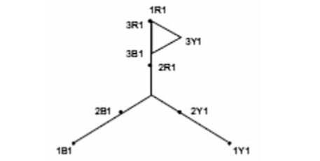
c) Procedure for the Test
1. Keep the tap position of transformer at normal
2. Short 1U of HV and 2U of LV
3. Apply 440 V 3 phase supply to HV terminals
4. Measure the voltage across the following terminals as below
5. Make conditions in the way of arithmetical and logical for verifying the phase angle difference

